**Athif Zakiyanto_QE Kelas A**

**Weekly Taks QE 3**

**POSITIVE CASE**

1. Fitur User “Thread Group”

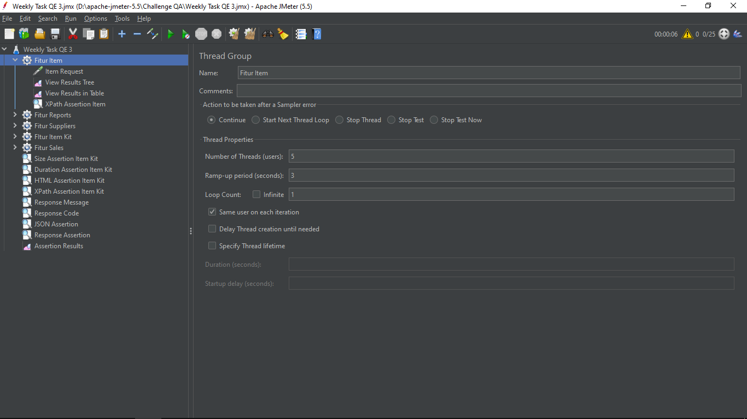

* Fitur items “HTTP Request” (https://demo.opensourcepos.org/items)

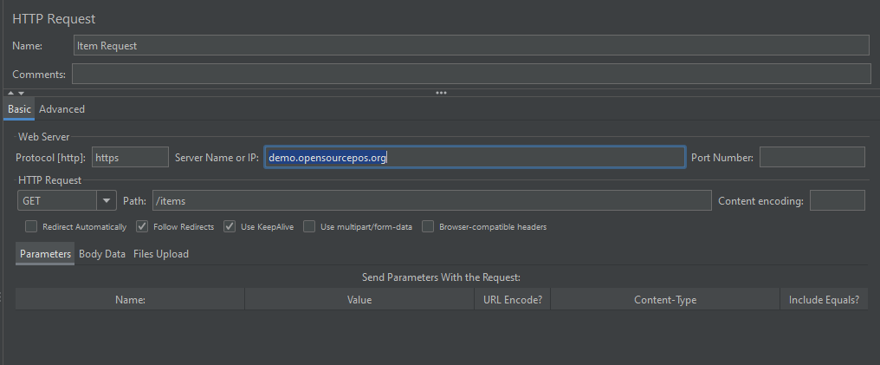

* View Result tree (Fitur Items)

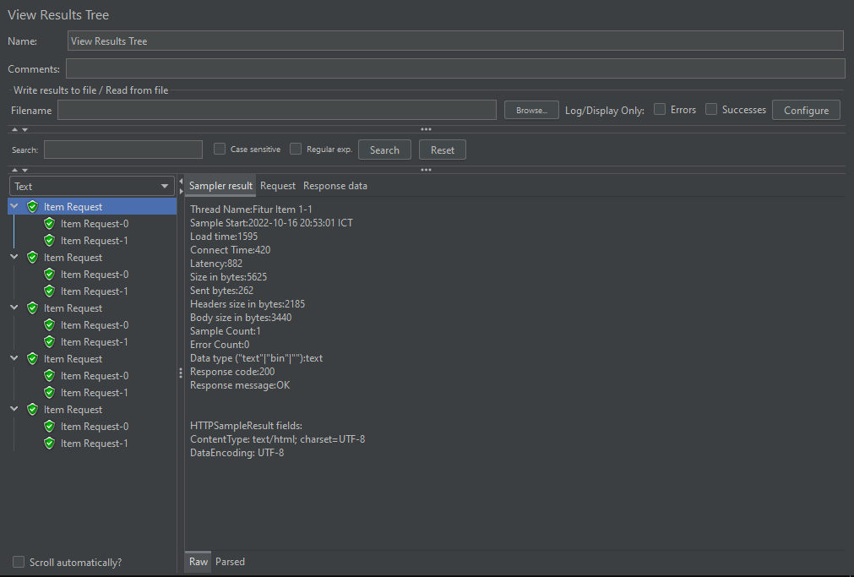

* View Result Table (Fitur Items)

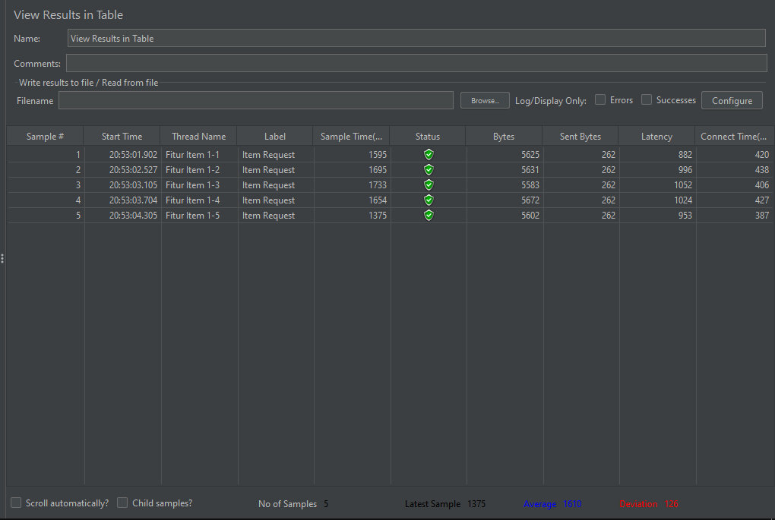

* XPath Assertion Item

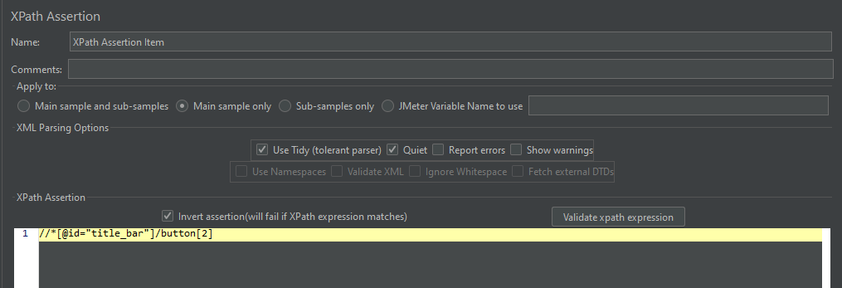

1. **Fitur Report “Thread Group”**

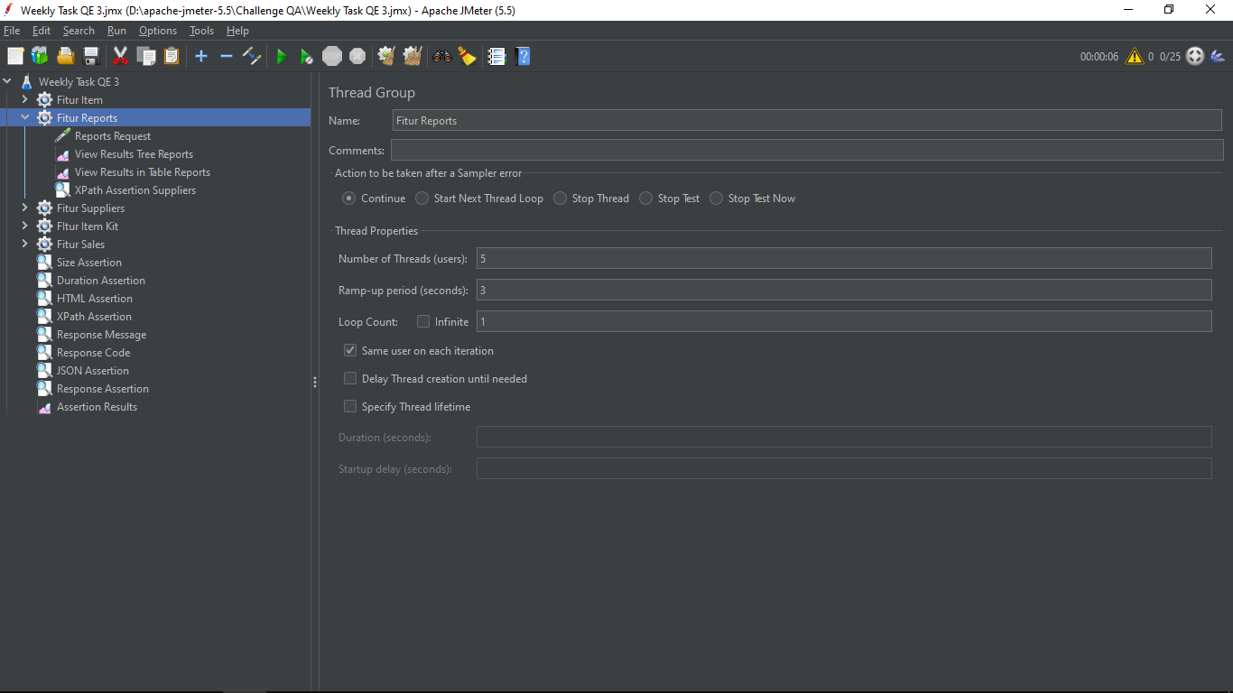

* Item “HTTP Request” (https://demo.opensourcepos.org/Report )

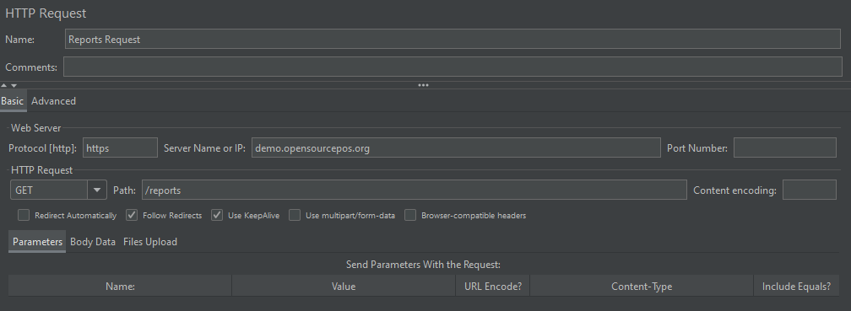

* View Result tree (Fitur Report)

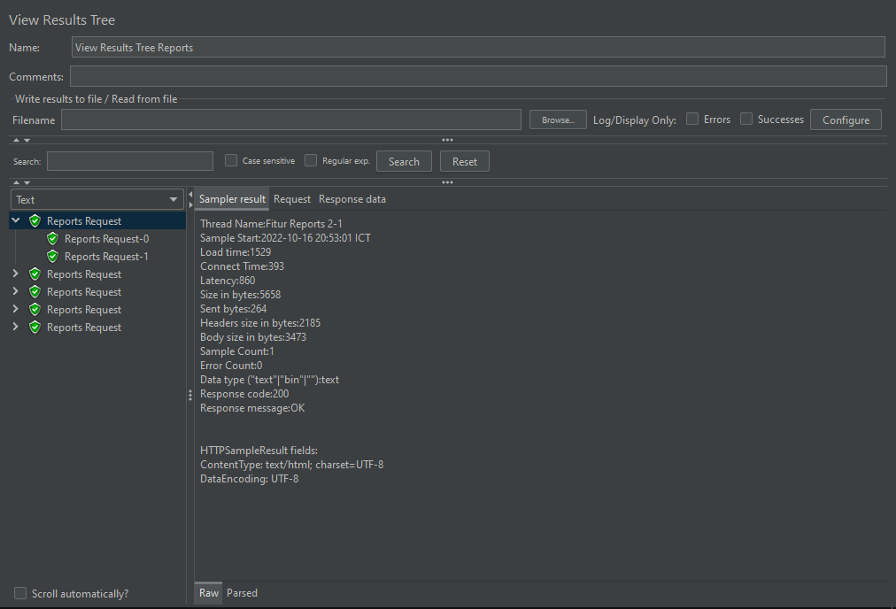

* View Result Table ( Fitur Report )

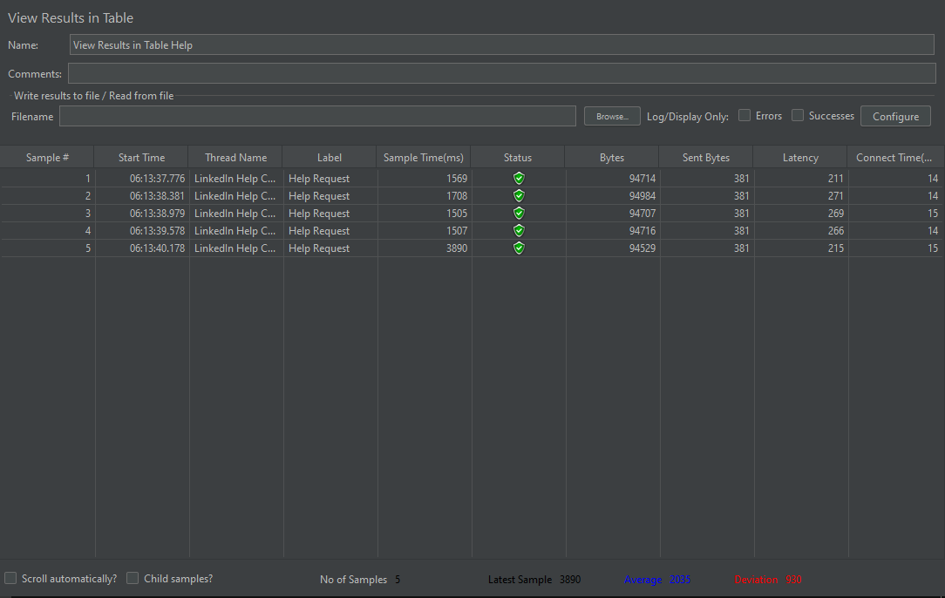

* XPath Assertion Report

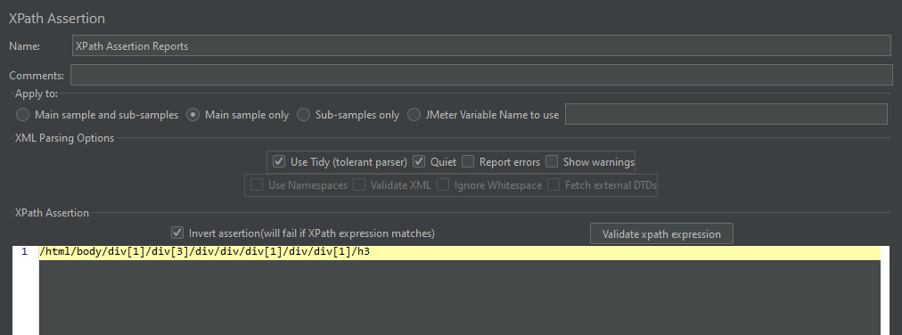

1. **Suppliers ‘Thread Group’**

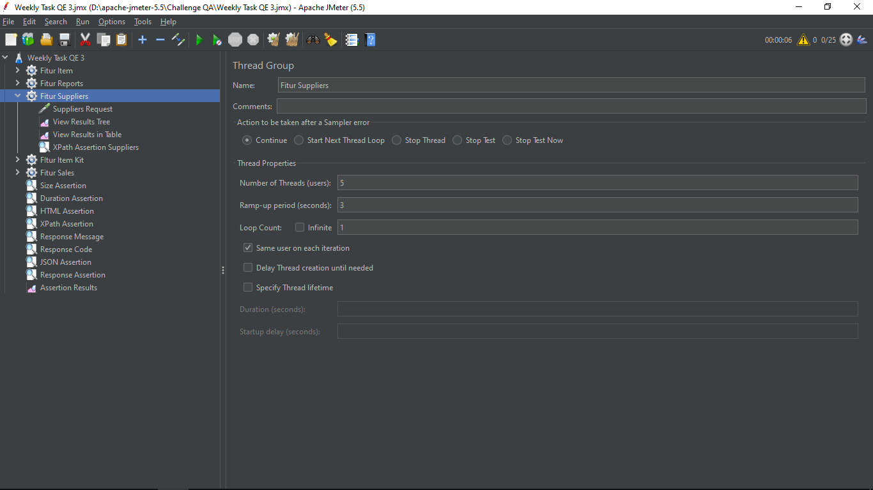

* Fitur Suppliers “HTTP Request” (https://demo.opensourcepos.org/suppliers)

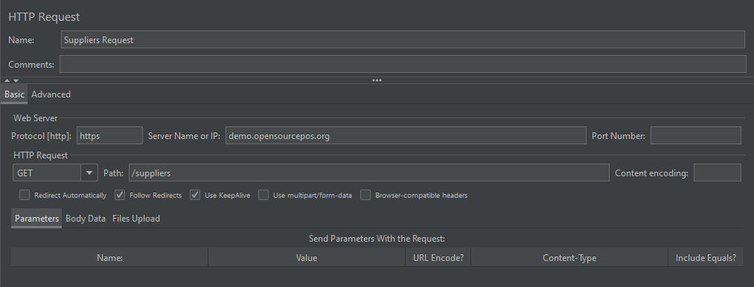

* View Result tree ( Suppliers)

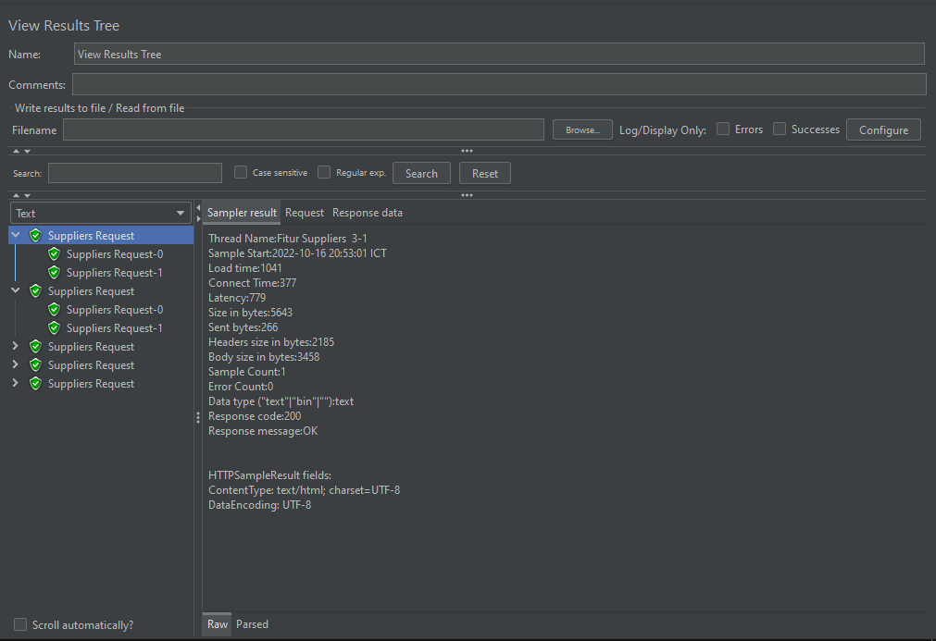

* View Result Table ( Suppliers)

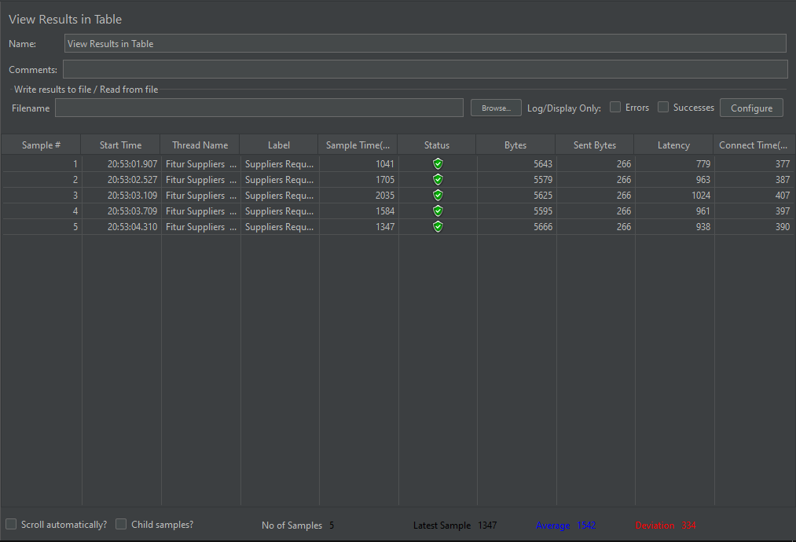

* XPath Assertion Suppliers

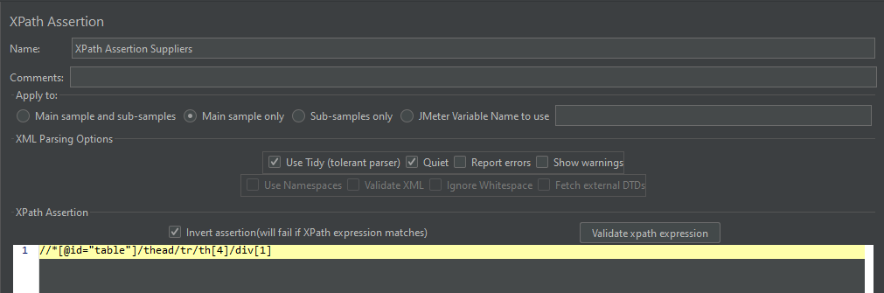

1. **Item Kit ‘Thread Group’**

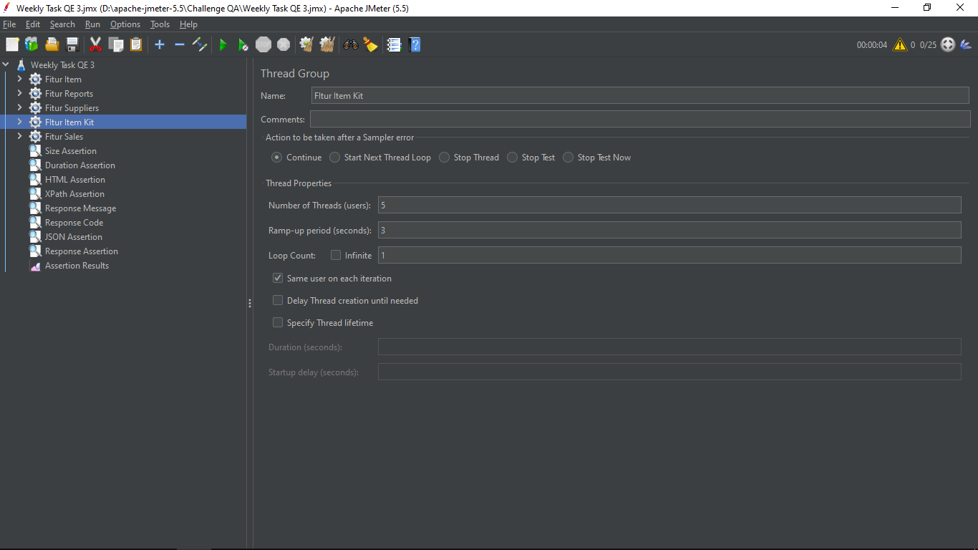

* Item Kit “HTTP Request” (https:// demo.opensourcepos.org.com/item_kit)

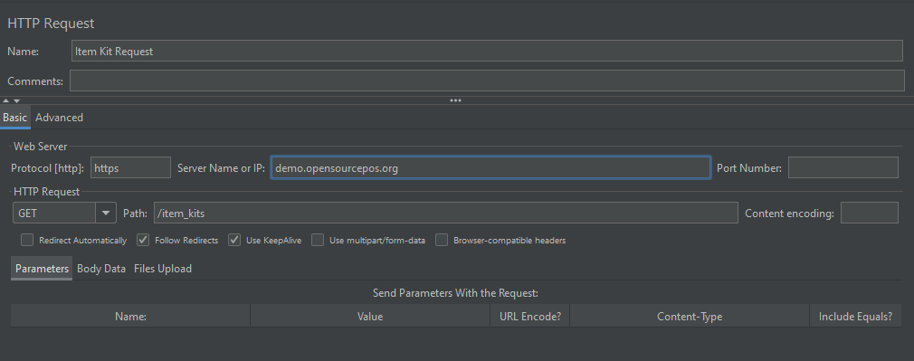

* View Result tree (Item Kit)

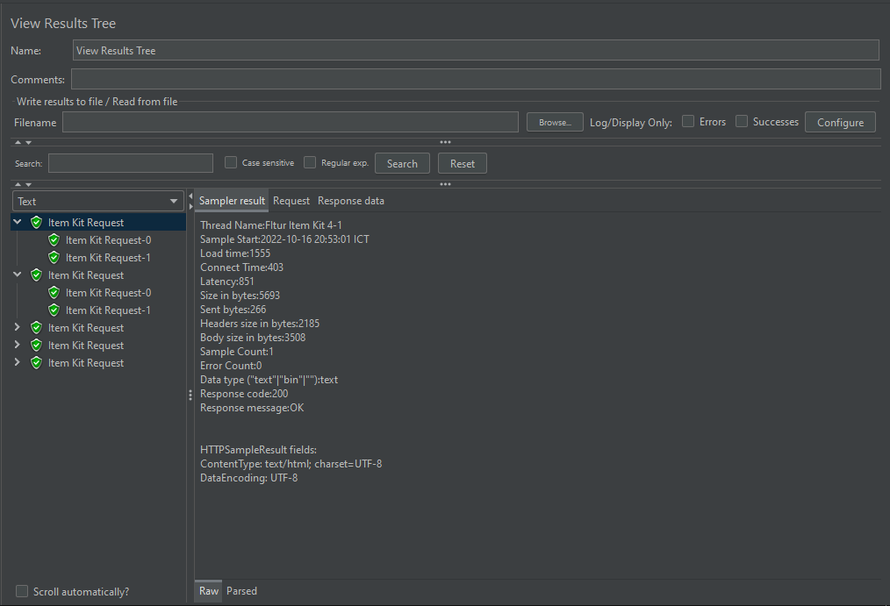

* View Result Table (Item Kit)

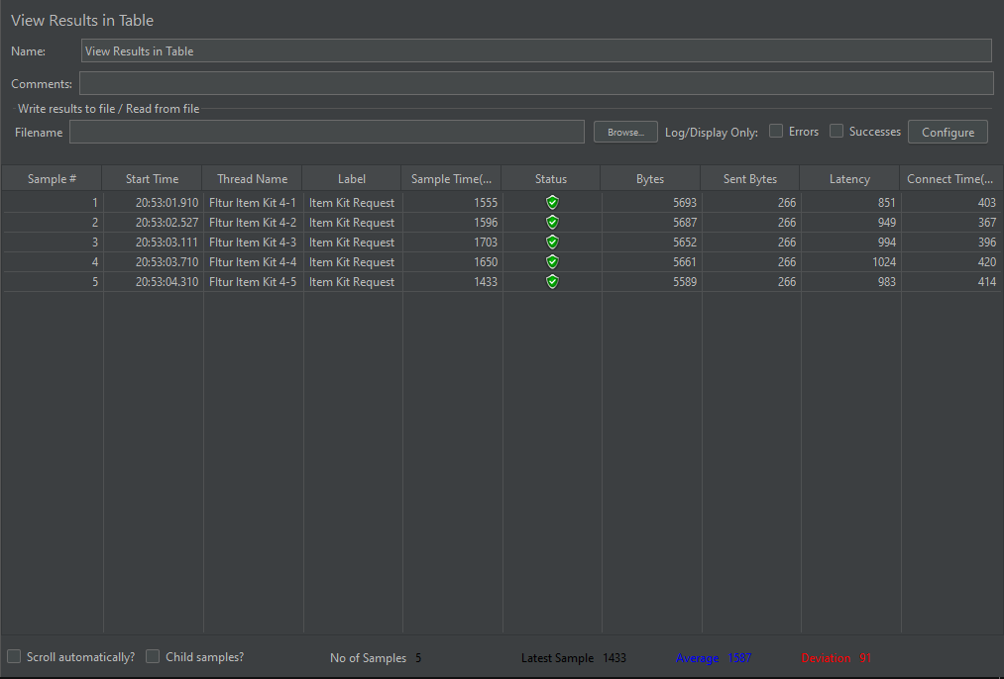

* XPath Assertion Item Kit



1. **Fitur Sales ‘Thread Group’**

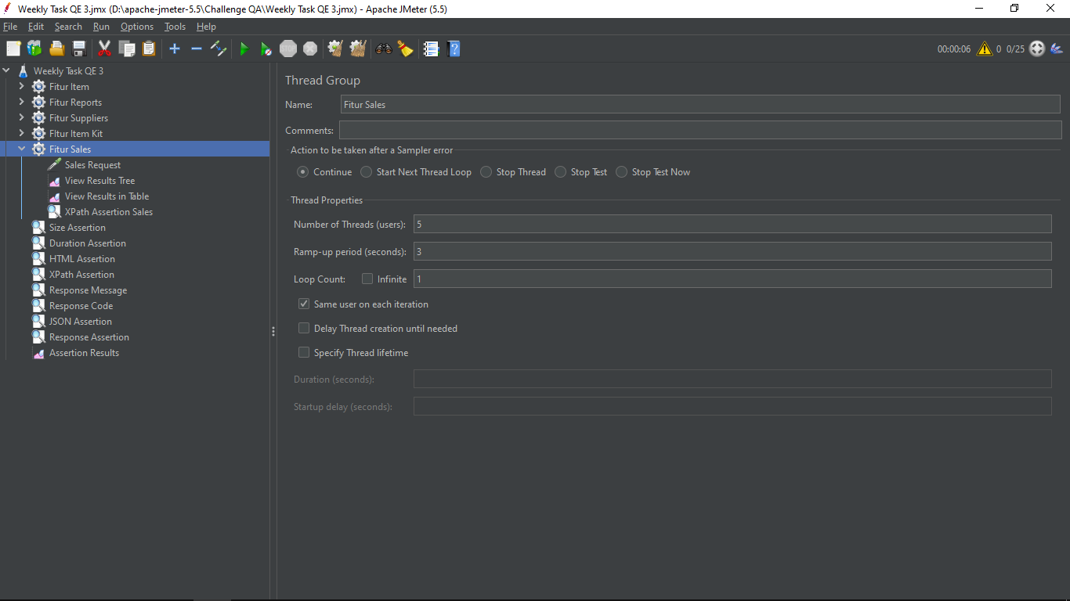

* Sales “HTTP Request” (https:// demo.opensourcepos.org.com/sales)

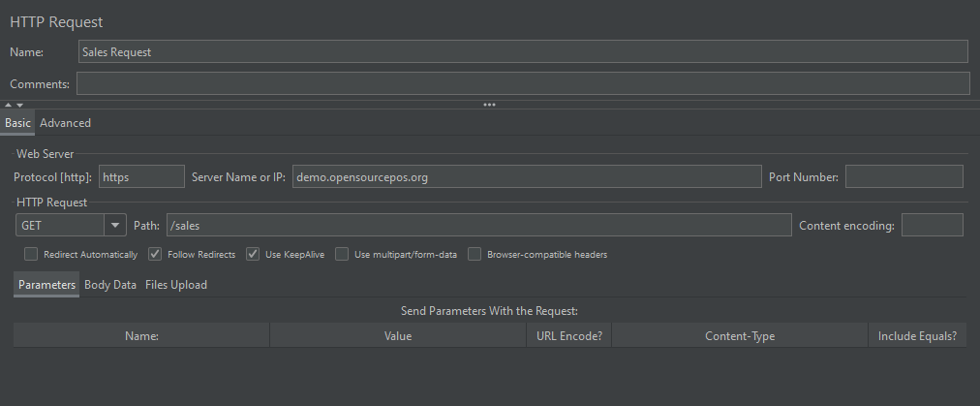

* View Result tree (Sales)

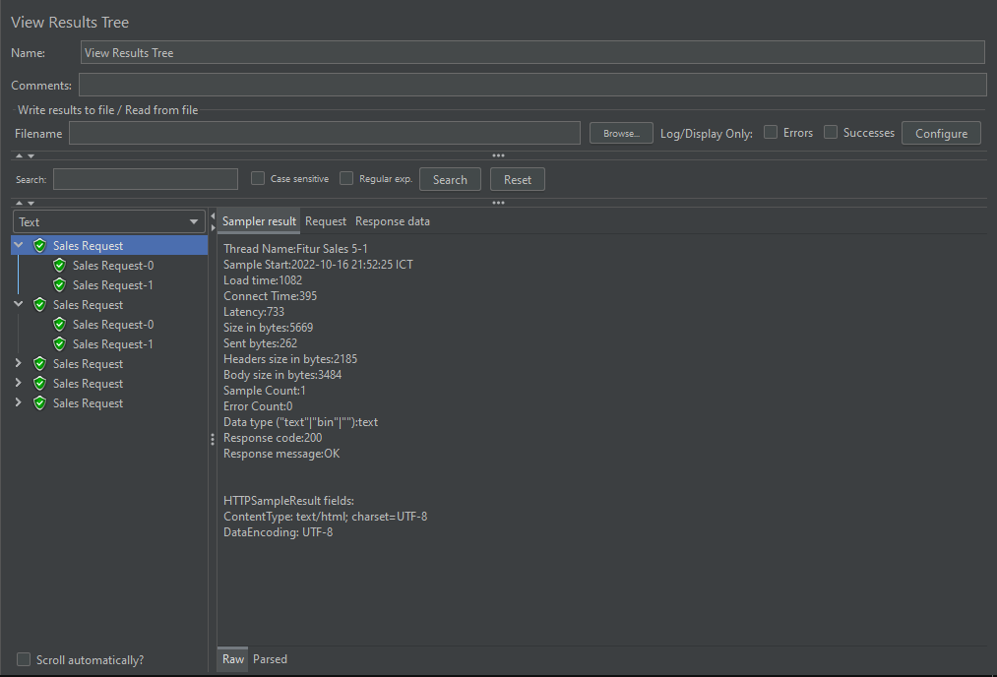

* View Result Table (Item Kit)

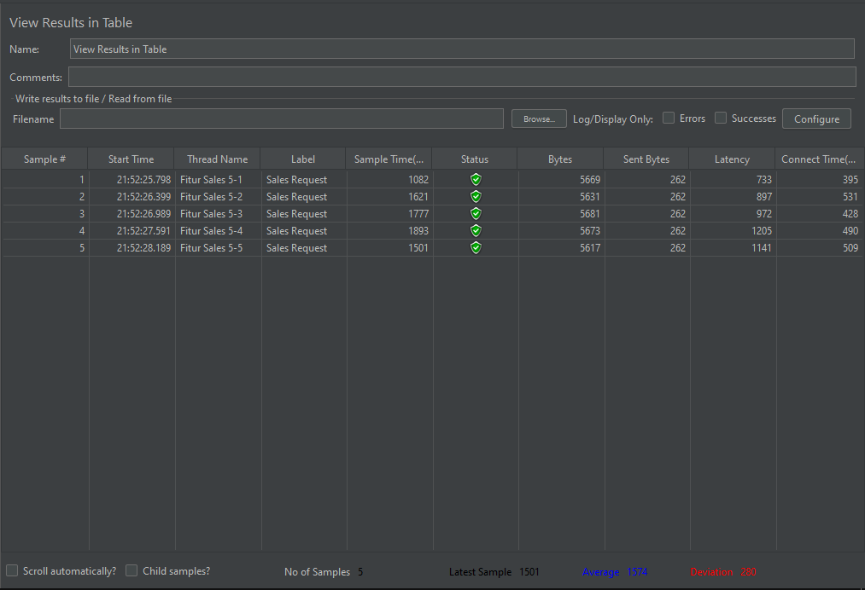

* XPath Assertion Sales

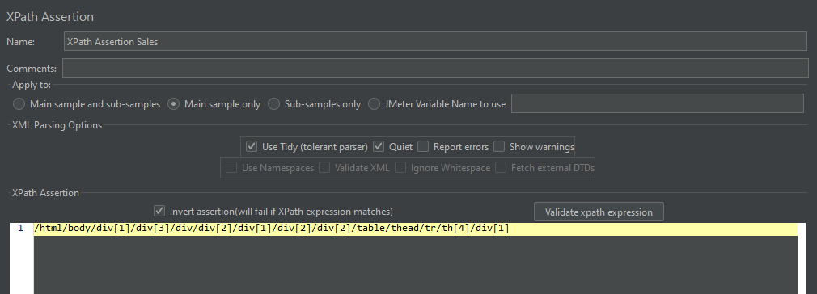

Untuk Size Assertion, Duration Assertion, HTML Assertion, Respone Message, Respone Code, JSON Assertion, dan Response Assertion karena memiliki format yang sama, maka disini saya menyamakan file tersebut dan meletakanya didalam folder Test Plan langsung.

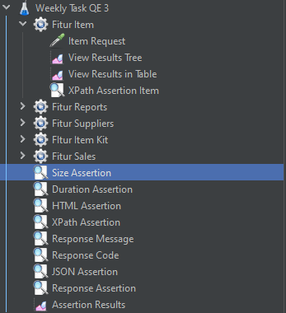

* Size Assertion

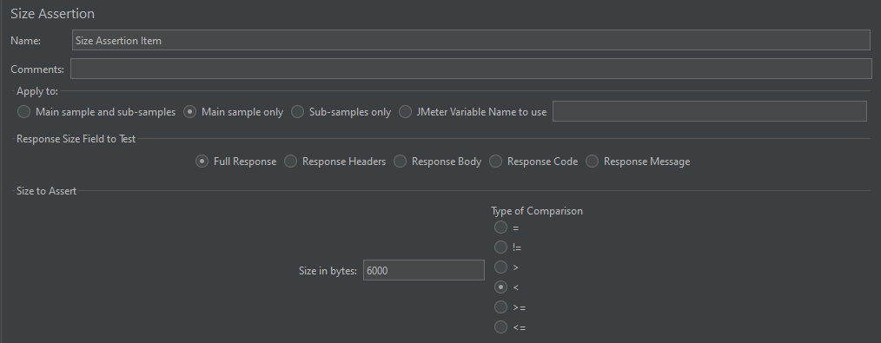

* Duration Assertion

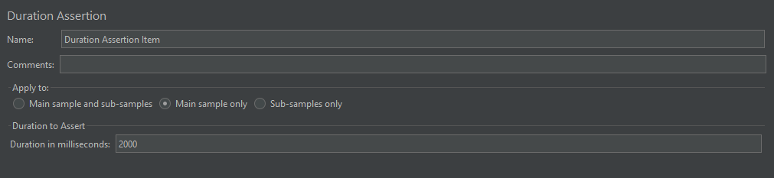

* HTML Assertion

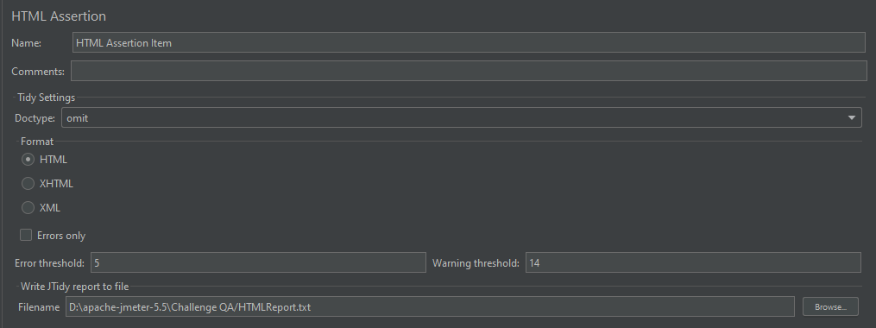

* Respone Message

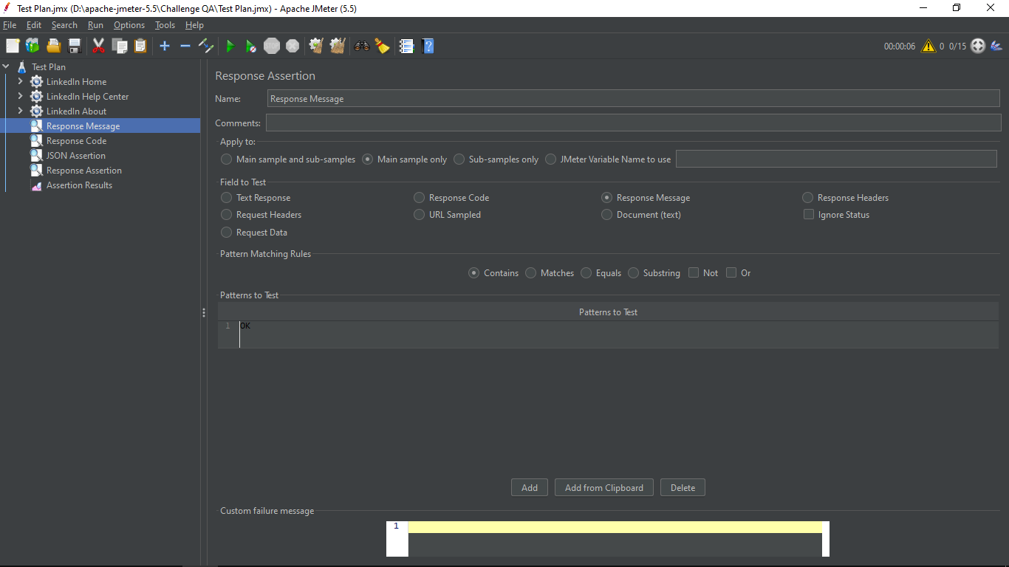

* Response Code

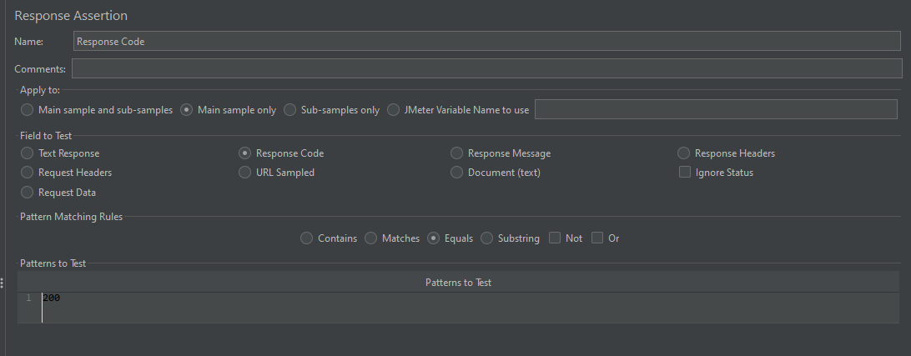

* JSON Assertion

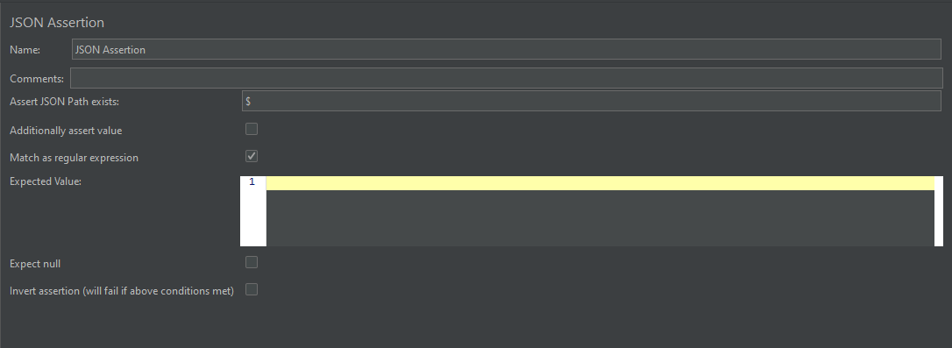

* Response Assertion

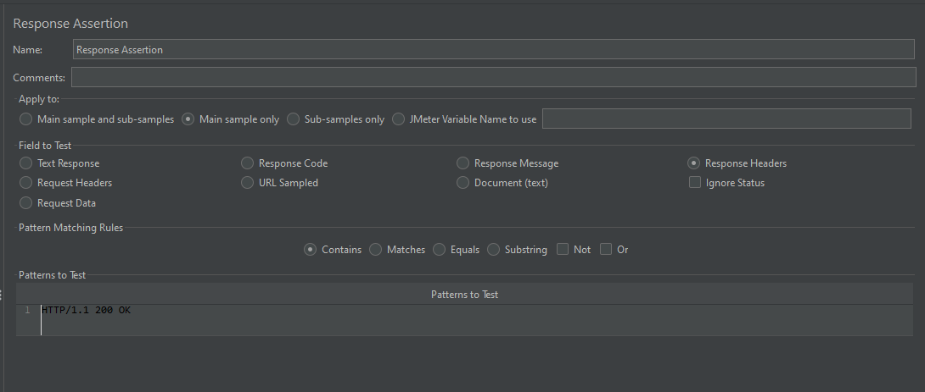

**Assertion Result**

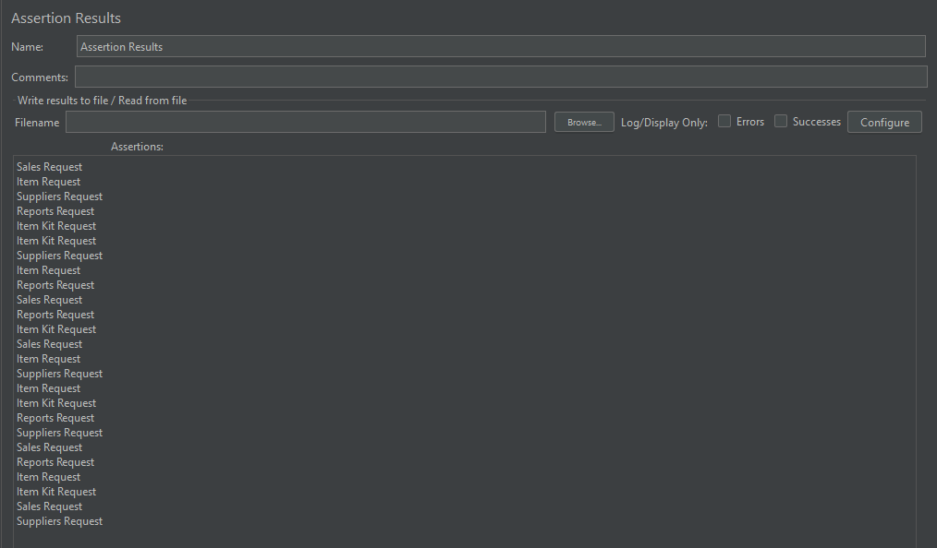

**NEGATIVE CASE**

1. Fitur User Negative “Thread Group”

- Number of Threads dibuat 20

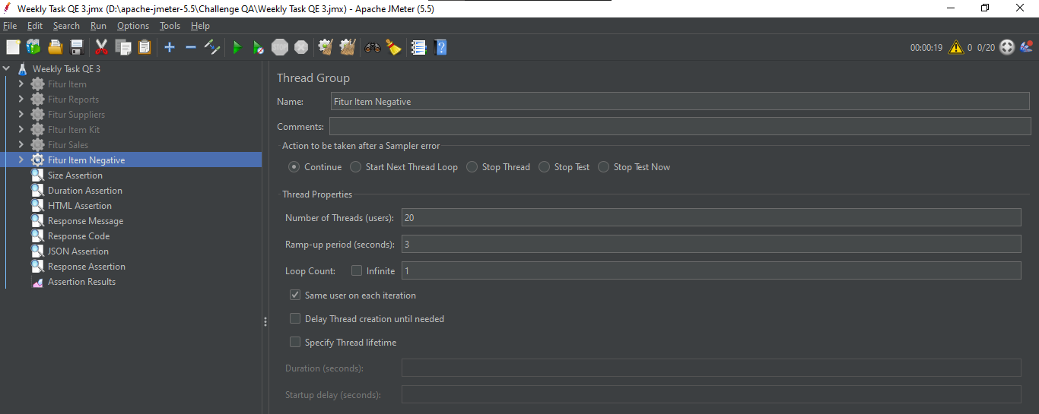

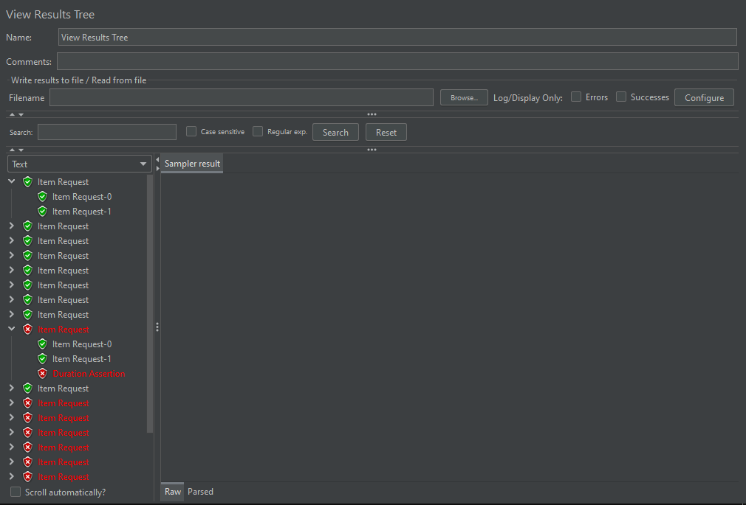

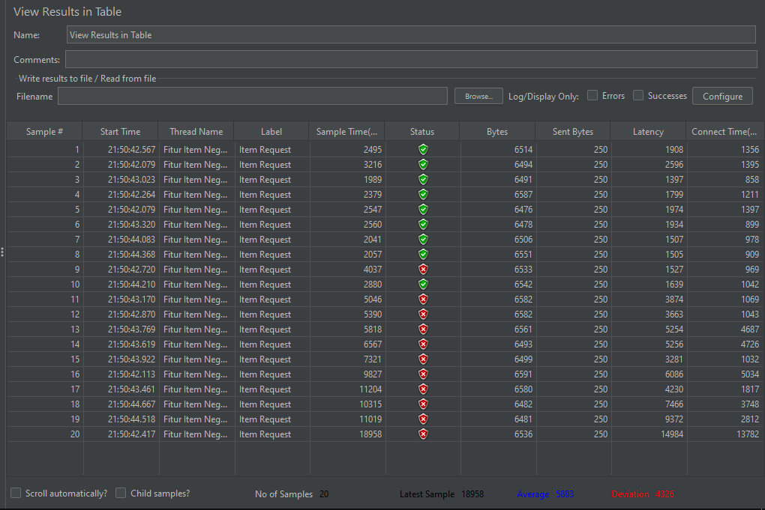

* HTML Assertion pada error threshold dibuat jadi 1 dan Warning Threshold dibuat jadi 1

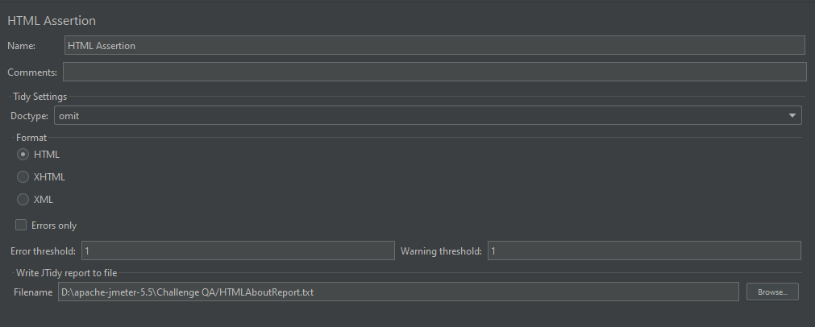

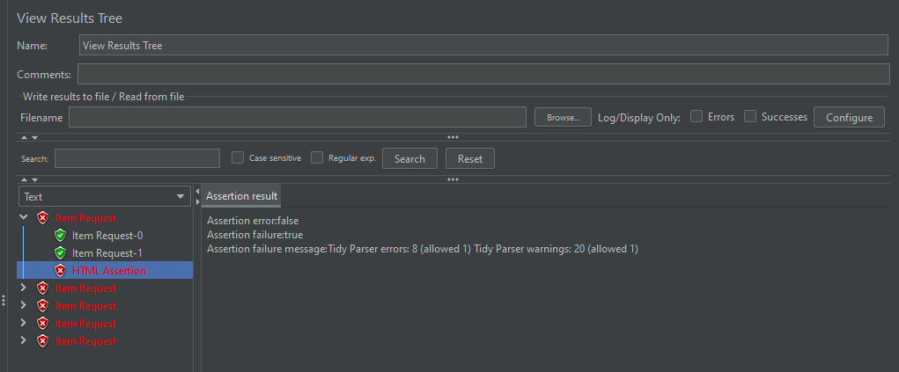

1. **Fitur Report Negative “Thread Group”**

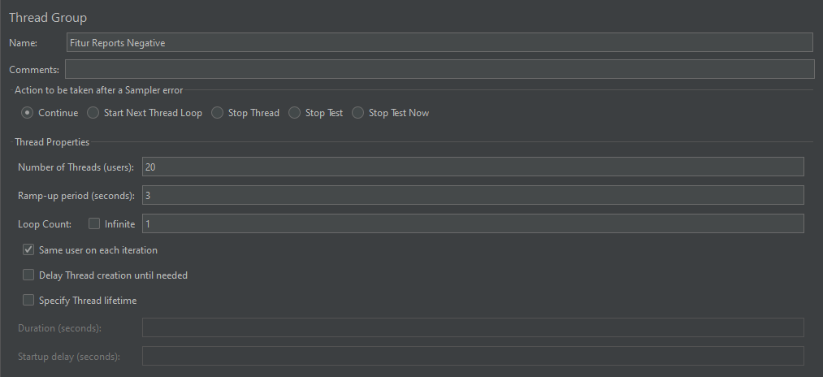

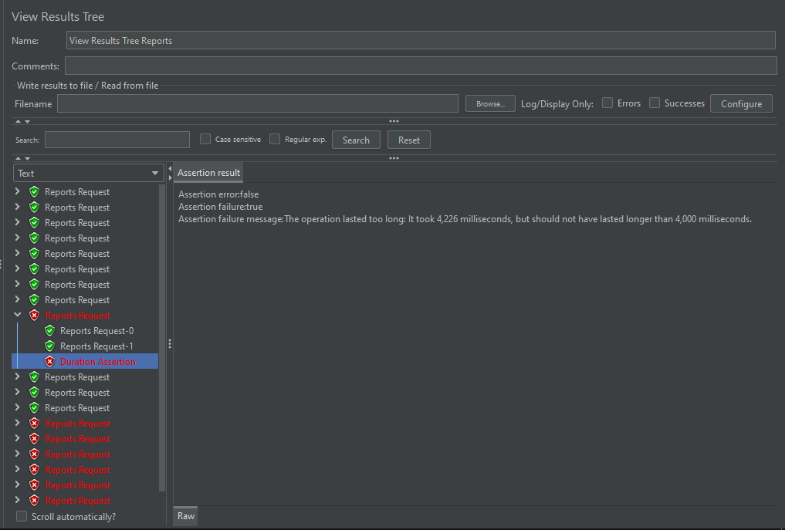

* Response Code dibuat menjadi 201

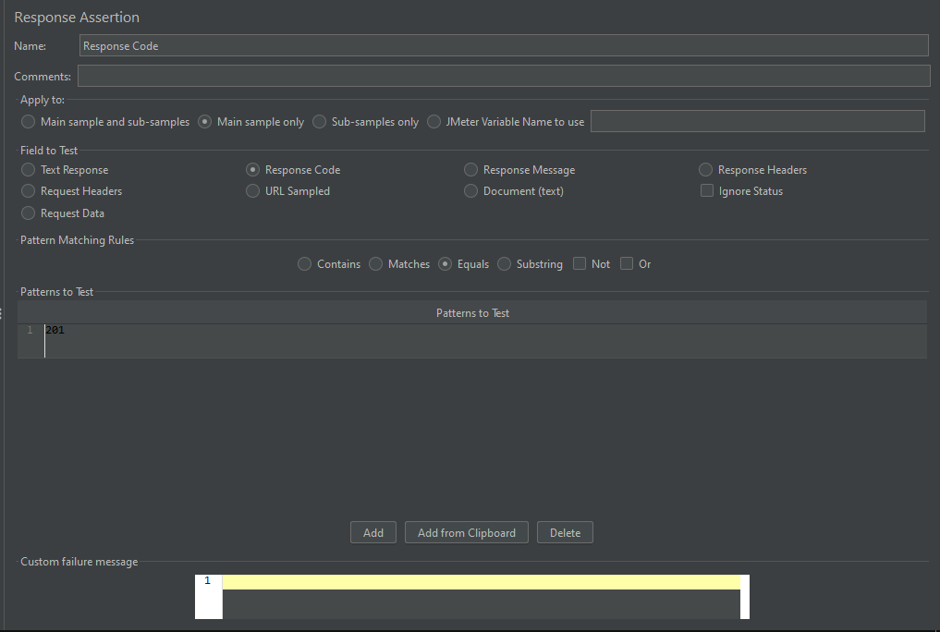

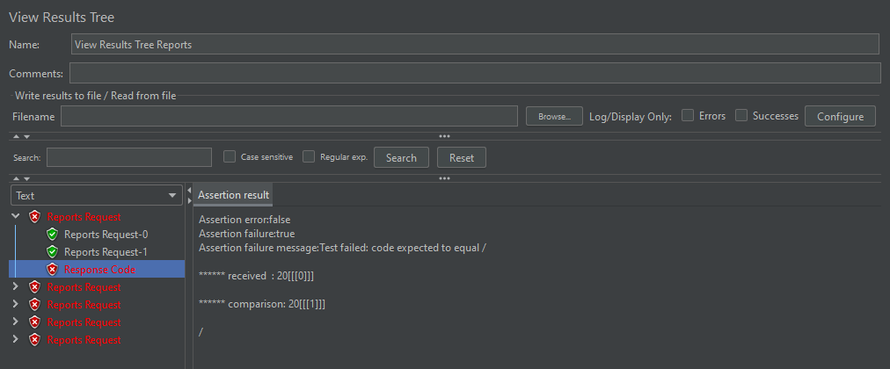

* Duration Assertion dibuat menjadi 100

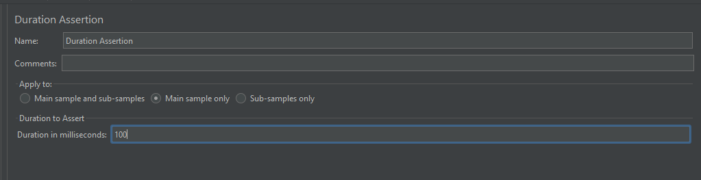

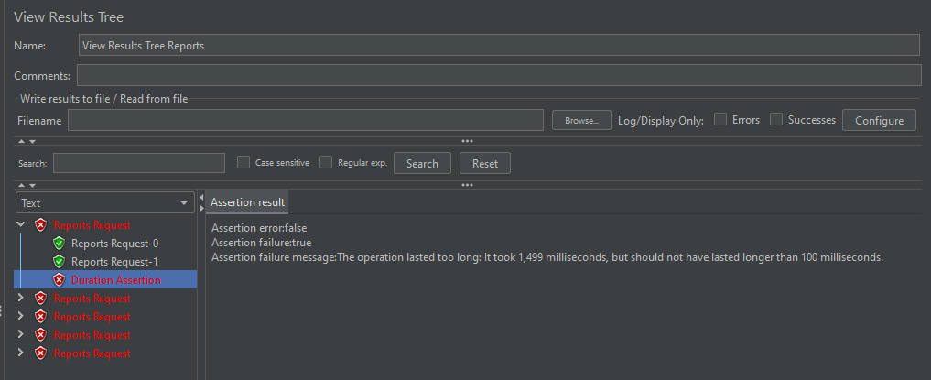

1. **Fitur Suppliers Negative ‘Thread Group’**

- Number of Threads dibuat 20

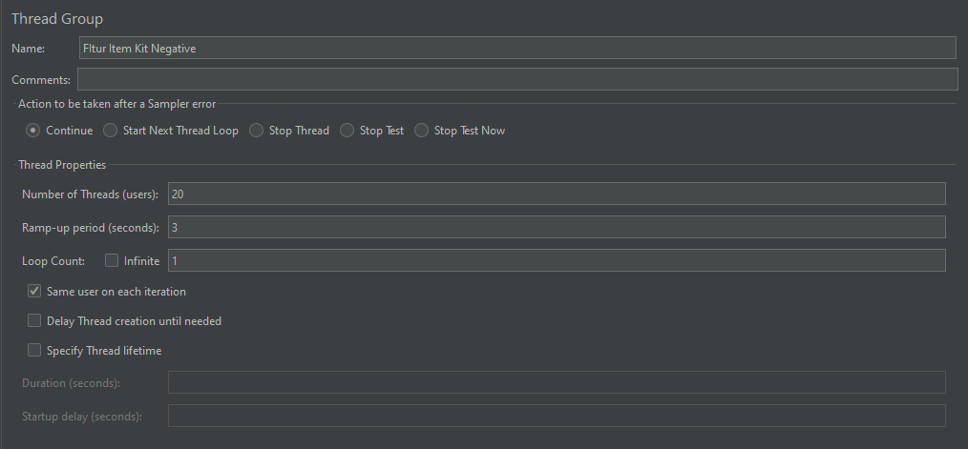

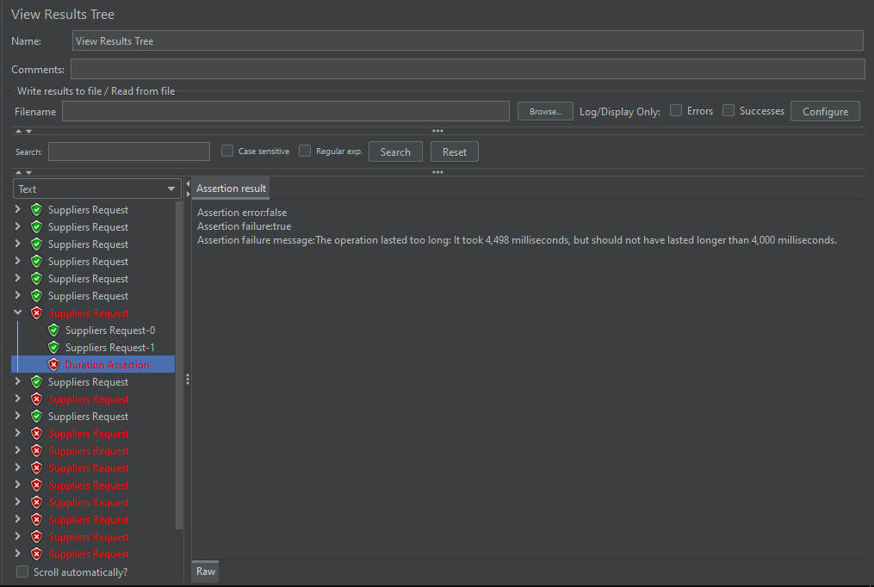

* Duration Assertion dibuat menjadi 100



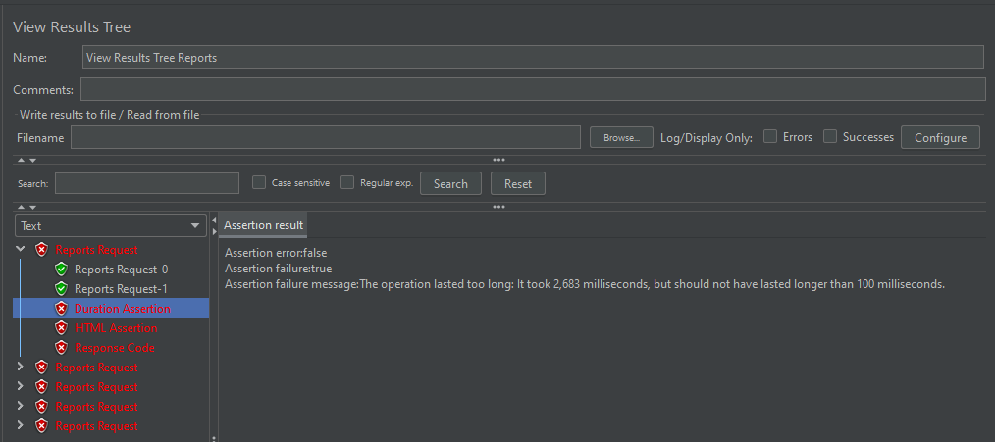

* Response Code dibuat menjadi 201



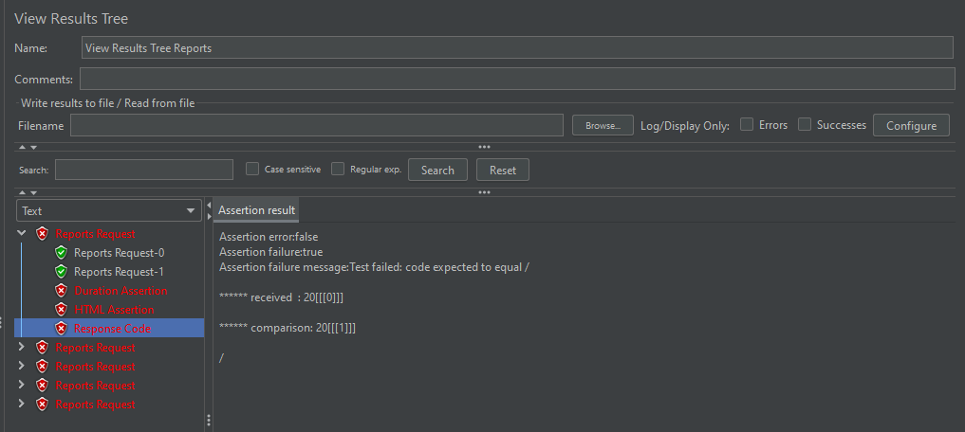

* HTML Assertion pada error threshold dibuat jadi 1 dan Warning Threshold dibuat jadi 1



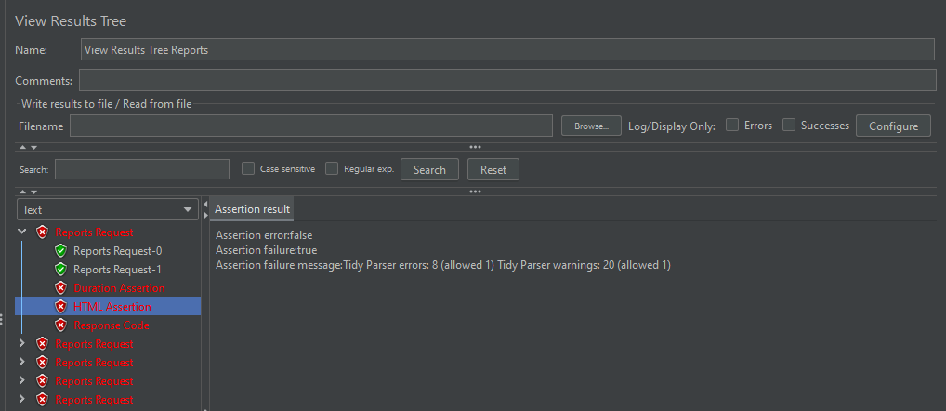

1. **Item Kit ‘Thread Group’**

- Number of Threads dibuat 20

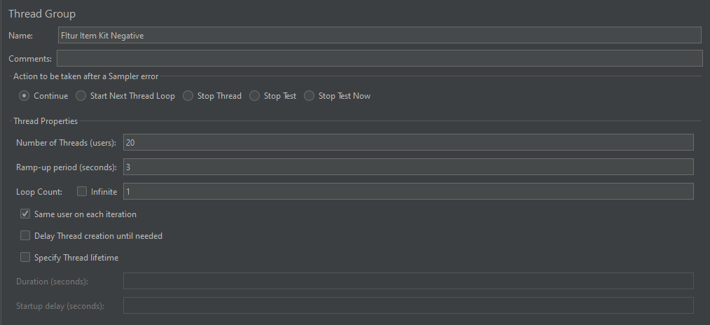

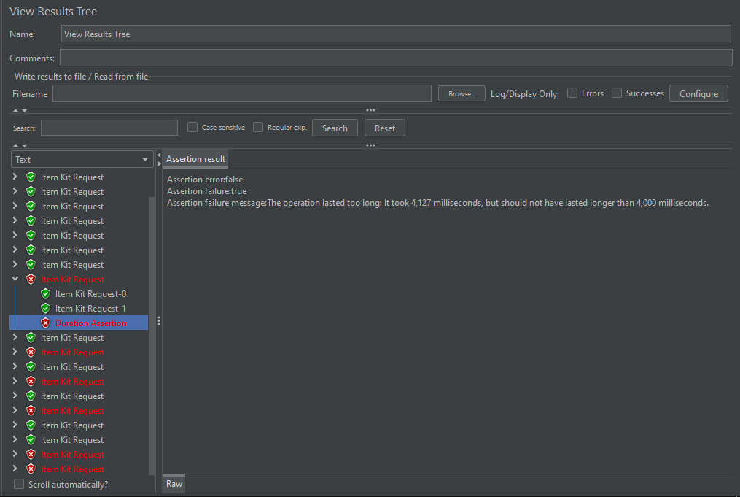

* Duration Assertion dibuat menjadi 100



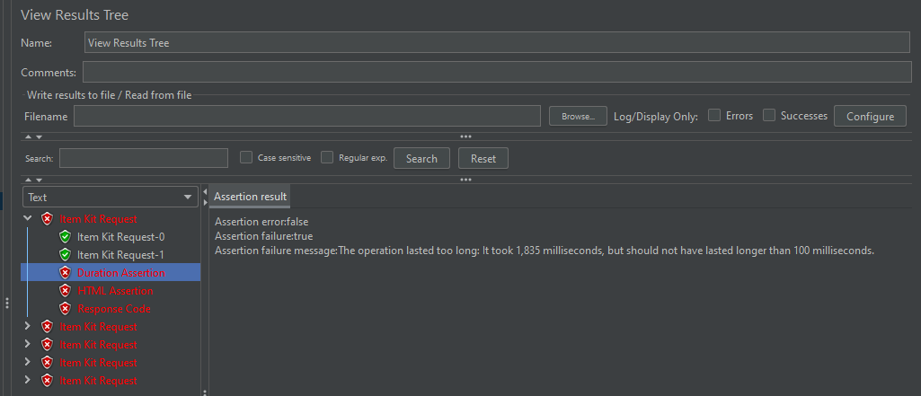

* Response Code dibuat menjadi 201



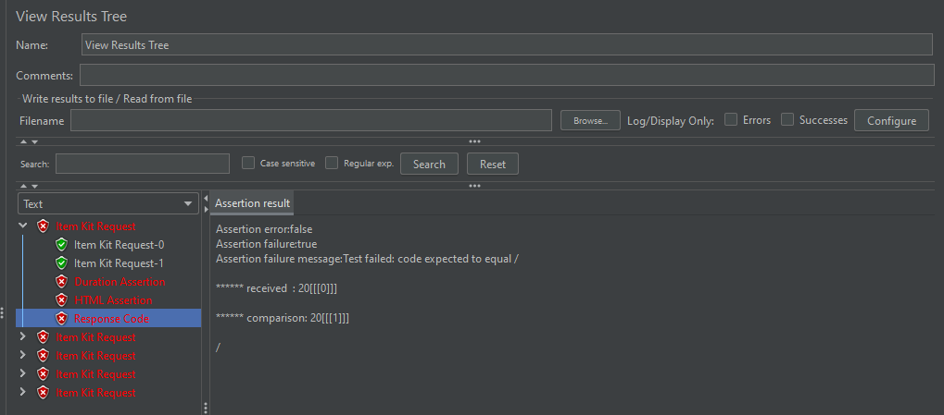

* HTML Assertion pada error threshold dibuat jadi 1 dan Warning Threshold dibuat jadi 1



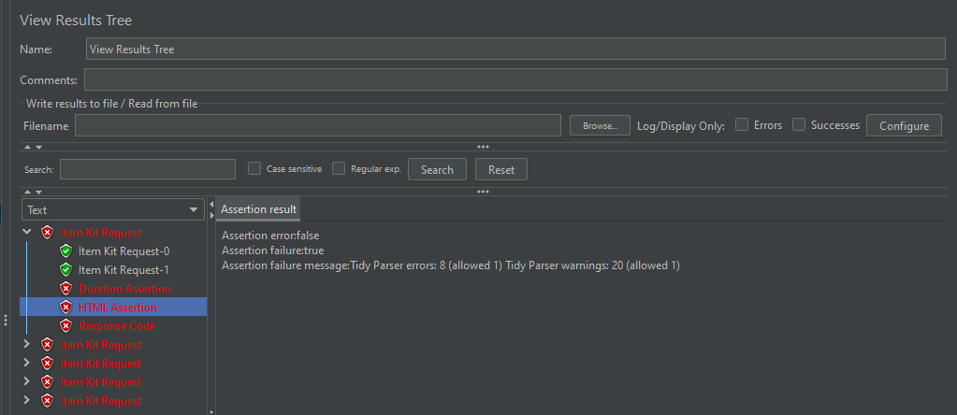

1. **Fitur Sales ‘Thread Group’**

- Number of Threads dibuat 20

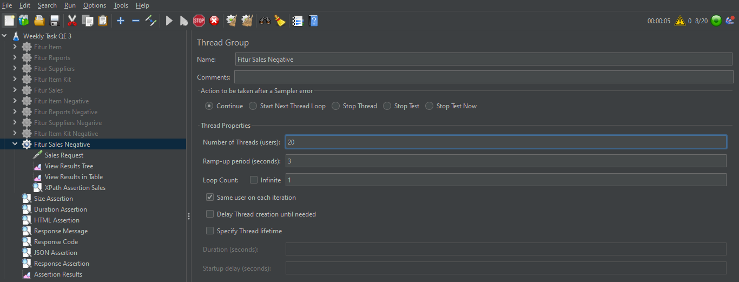

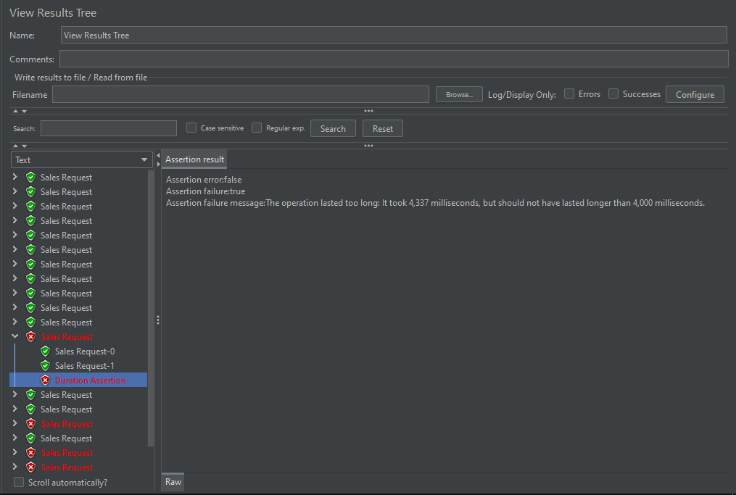

* Duration Assertion dibuat menjadi 100



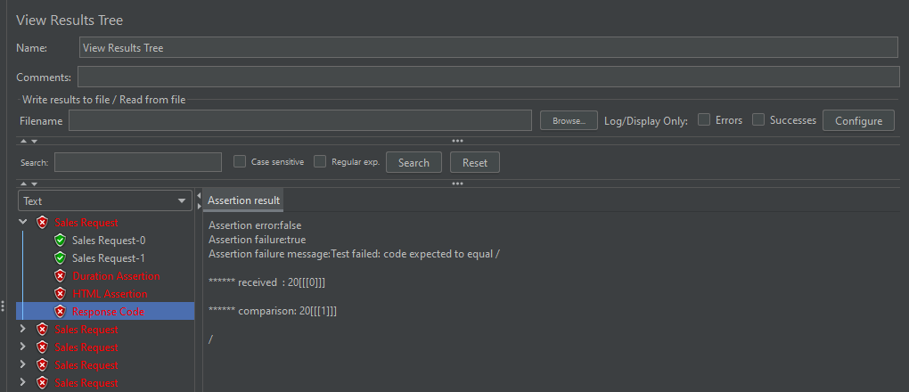

* Response Code dibuat menjadi 201





* HTML Assertion pada error threshold dibuat jadi 1 dan Warning Threshold dibuat jadi 1



